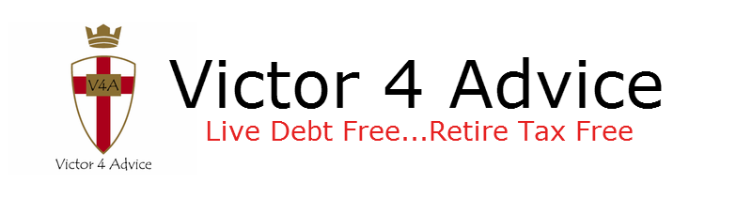
Victor 4 Advice ● 2810 Tara Ct. Opelika, Alabama 36804 ● 770-714-6795 ● victor@victor4advice.com

Instructions for completing the Infinite Banking Financial Data Form

Let me begin by emphasizing that I want to do the best possible job for you. The idea is to get you out of debt soon, and show you a way to stay out of debt to anyone else. I want you to be able to create a private family bank that will allow you to borrow again in the future for your family needs. But you will borrow from your bank and pay it back with interest. This creates wealth over the long term, an asset that continues to build for your lifetime, guaranteed and tax free. Then your bank can pay you a tax free income in retirement to supplement your other retirement streams of income such as social security, 401ks, IRAs, pensions, etc.
As a licensed professional, it would be irresponsible of me to give you financial advice at this level without having the basic information about your financial situation. It would be like a doctor giving you medical advice without knowing your medical history. Because of my licenses and the ethics of my profession, I am obligated to keep your information confidential.
With this is mind, please complete the financial data form as accurately as possible and return it to me right away so we can get you started. Thank you.

Page 1: Don’t worry about Agent Name. I complete that. For income, you can put Gross income / net income on a monthly basis for both spouses on that first line where it says wages / salary. Your net income is what you actually take home after deductions for taxes and employee benefit deductions.
Desired retirement income is important. Whatever you do in life financially, you’ll need to know if it will get you to your ultimate goal, a comfortable and secure retirement.
Tell me about any foreseeable changes in cash flow: imminent pay raise, inheritance, sale of assets, etc.
List all your financial assets in the bottom section. For 401ks at work, you can put what comes out of your pay each pay period, add it up for the year, and divide by 12. Do not include company match. Even though there’s not a space for it, at the bottom of the page, please let me know what percentage of your pay you contribute to your 401K. Also I need to know up to what percentage of your pay does your employer match. Ex: My employer matches 50 cents on the dollar up to 3%. I currently contribute the 3%, or you contribute 5%, 10%, etc.
Under the “Int. %” column…that only pertains to money in savings or money market accounts…any accounts that actually pay an interest rate. Money in the stock market doesn’t do that.
Listing monthly contributions is important. Account value doesn’t have to be to the penny, but in the ball park at least.
Don’t worry about the “Available YFB” column. I will discuss that with you when we meet.

Page 2: Mortgage information…please only list the principal and interest. It’s right on the mortgage statement you receive each month. All the information requested is important. I will put that into a software program with Money Mastery to create your debt elimination plan. It may take a little work to come up with the info. For me it’s easy. I just go online with my lender. Once I bring up my account, I can see my outstanding loan balance, the interest rate, and how many of 360 payments I’ve made. So I can easily see how many years (or months) remain on my mortgage. You should be able to do the same thing with your lender. Or you can call them for the info. You can also go to your original loan docs and figure it out the long way.
If you have a second mortgage, you can list it the same way. If you have a line of credit on your home, list that on page 3. If you have rental properties, let me know. I will need to consult with you further on that. Don’t list them here for now.
Life insurance information is important. If you have cash value life insurance, I will need to know the current cash value. You can look at your last annual statement or call the insurance company for the up to the month cash value, or surrender value.
“Any Assets not listed” would include things like rental property, raw land, time shares, collectables, gold and silver coins in a vault, a business, second home, etc. Basically things that have value that add to your estate’s worth. I will go over these with you to include their value when we meet.

Page 3: List all other debts here. I need the amount owed as exactly as you can give it. You can get that off your statements. Put the exact interest rate without rounding off. List the minimum payment that’s on your statement. If you pay extra on a certain bill, list that. Ex: Minimum payment is $120.00 on the Visa card. But you pay $50 each money extra on it. So the Actual payment is $170.00. Don’t leave off any debts unless you will for sure pay them off within three months.
Again, it is important to list this information accurately. I will input this into the Money Mastery program to create your debt elimination plan.
At the bottom, check off your current concerns. If a concern of yours is not listed, please write it in. I want to make sure all your concerns are addressed.
List any future expenditures like buying a car next month, wedding, having to pay for a child’s college or yours soon, needing to replace your HVAC unit next month, etc.

Well, that’s it. This may take you an hour, but it’s well worth it. First of all, I need the information to do the best job for you. But it’s also a great exercise for you to see at a glance what your financial life looks like. You will want to keep a record of it to compare with what your financial life will look like in 5 years, 10 years, and further down the road of life.
When you have completed the form, you can scan and email me the form, or you can fax it to me at 888-205-9953. No cover sheet is needed.
God Bless you in your endeavors.

